Johnny’s Run – 7.75m of Gallaimh

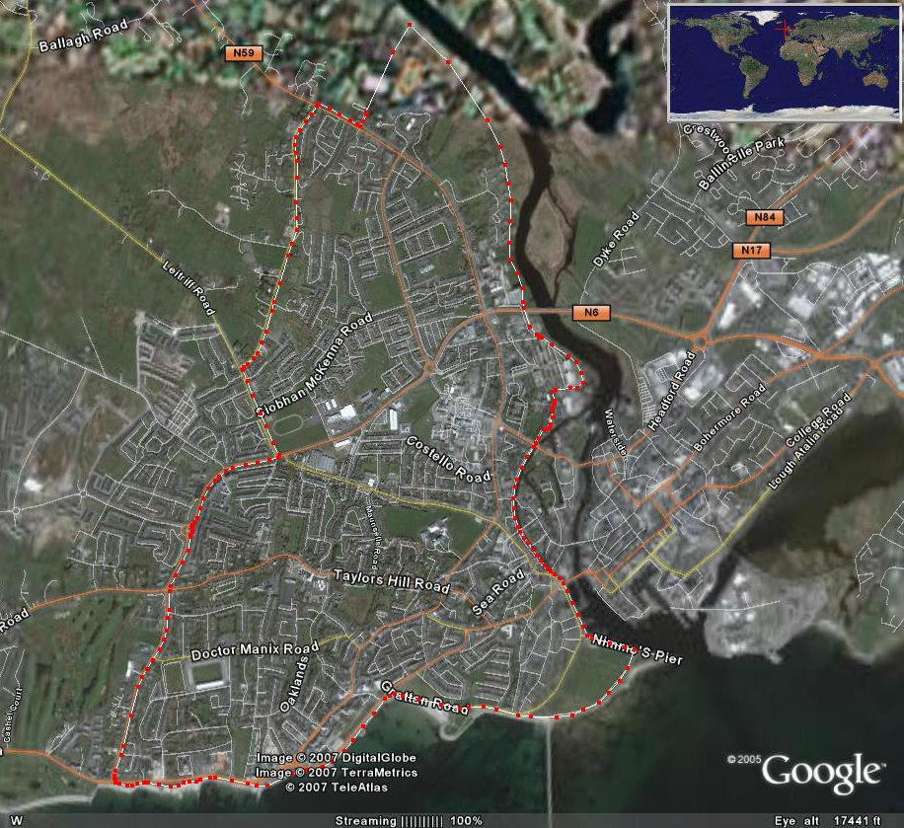
This route, supplied by Johnny O’Connor, follows a watery course around the west side of Galway City. Running along river, canal and Galway Bay be careful you don’t get wet!
Start & Finish at Dangan. NUIG Sportsground Carpark
Through University
Along River Corrib
Circular Rd
Along Canal
Threadneedle Rd
The Prom
South Park
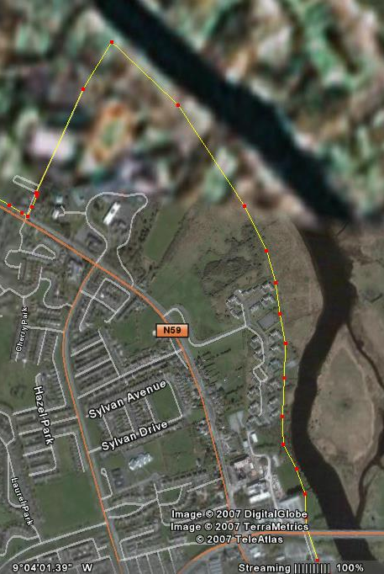

One of my favourite routes starts at the carpark in the Dangan sportsground and works its way towards the NUIG campus via the Corrib riverbank. During hot summer days there is always some activity along the river to pass the first mile, which helps the burden of loosening out. Rowers in training, water skiers catching their boats wake, swimmers on a quest to cross to Menlo castle or simply some wildlife basking in the sunshine.
Carpark

Quinncentenial Bridge
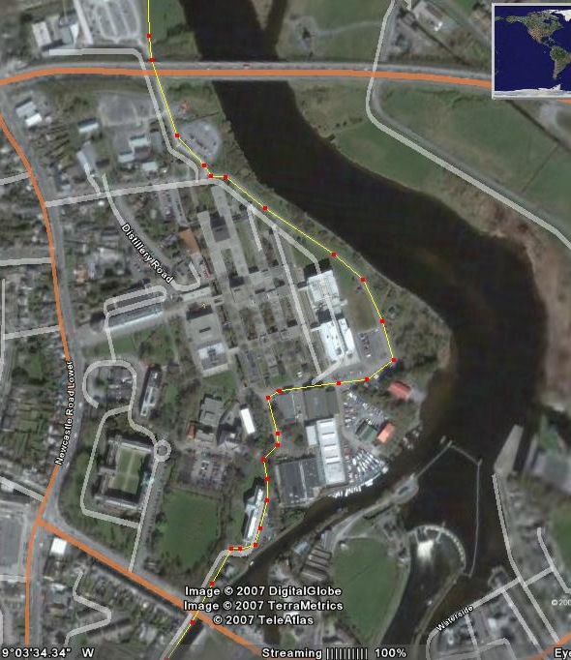

Upon reaching the university, the shade of the trees is welcomed as the Eglinton Canal approaches from University Road.

University

Canal

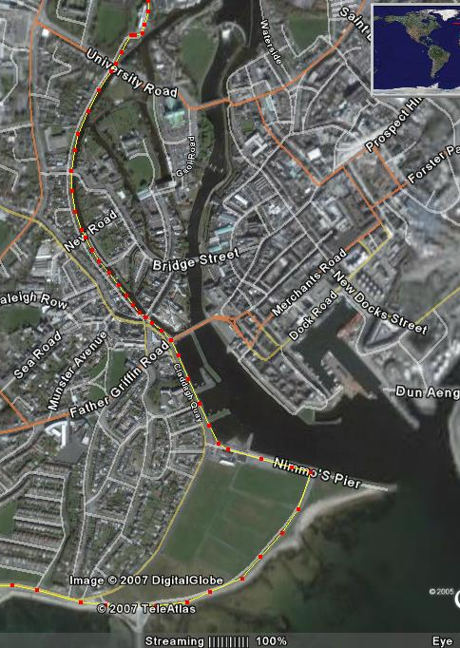

This canal was a navigation channel from the Claddagh Basin to Lough Corrib and stretches quietly from here to the bottom of Dominic Street crossing under Presentation Road and New Road where it almost meets the waters of Galway Bay blocked only by the gates of the basin.
Canal

The Claddagh
South Park
The route automatically draws onto South Park and along Salthill Promenade taking in Whitestrand and Grattan Road which at high tide is a pleasure to run beside. A bit of work starts as soon as the right turn at Blackrock diving boards is taken. All the way to the top of Threadneedle Road should leave you out of breath for a minute or two but the 1/2 mile down hill to the next set of traffic lights will bring you back to an easy 2-2 breathing pattern.

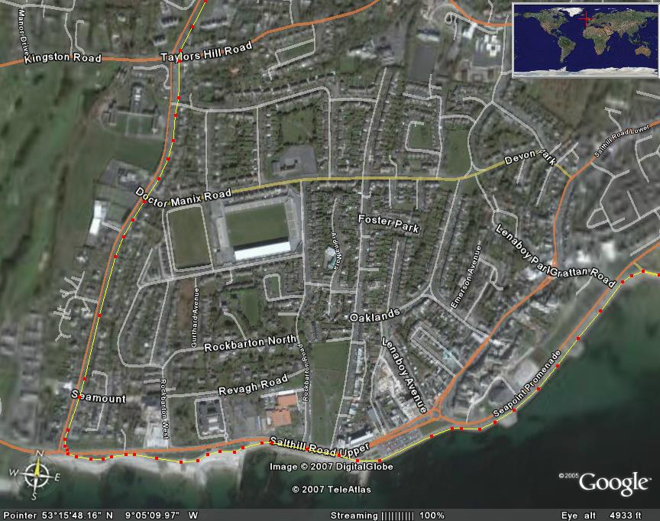
Seapoint
The Prom
Threadneedle Road

Circular Road
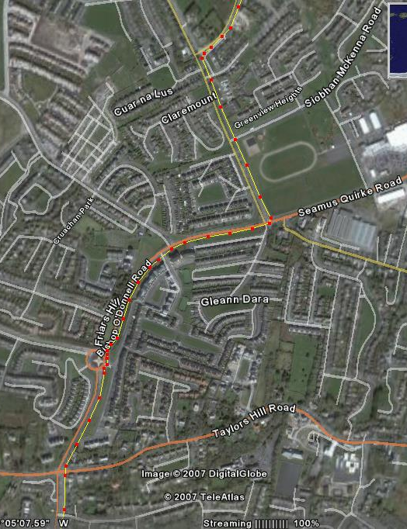
At these lights, which are just before the Westside Shopping Centre take a left and head up towards and turn onto Circular Road which is about the third turn to the right (800m).

Westside Shopping Ctr

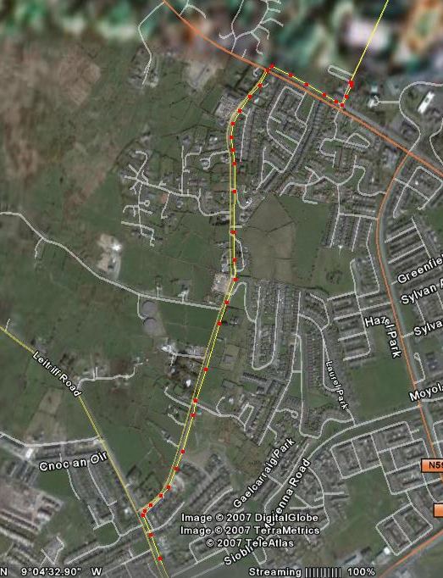
Finish at Dangan

The crest of Circular Road has a wonderful view of Galway City and is well worth the effort. Almost done as you leave this view behind and head back to Dangan taking a right turn on the main Clifden Road T-junction on the Bushy Park side of the route.
Clifden Road
Circular Road

