GOAL Kayathalon Registration Form

e-mail: goal.kayathalon@hotmail.com  phone: 087 6695064 (Seán)  086 1733610 (Ali) | 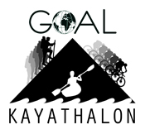

Personal Details

Name:
Representing:
Address:
E-mail:
Phone:

Equipment

Fill out the table below if you require any gear. (Yes or No)

Bicycle:
Kayak:
Buoyancy aid:
Paddle:

Please return you completed registration form as soon as possible to insure participation to goal.kayathalon@hotmail.com (as an attachment).

Sponsorship cards and sponsorship flyers will be posted out to each
participant before March 10th.

